Control Lesson 3

1. Sebastian Introduction

<https://www.youtube.com/watch?time_continue=2&v=tS9oGNg4oLY>

1. Intro to 2D Dynamics

<https://www.youtube.com/watch?v=DsSlWKIJ4sk>

1. Underactuation

<https://www.youtube.com/watch?v=Q6dJA8HhAWU>

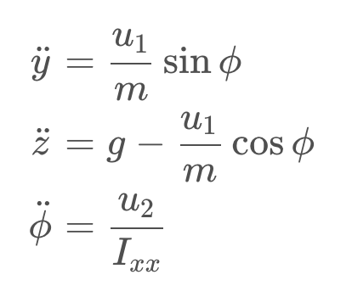

Since a 2D drone only has two control inputs, we can only simultaneously control two of its three degrees of freedom.

### **QUIZ QUESTION**

A real quadrotor has four controllable quantities (the four propeller rotational speeds) and 6 degrees of freedom (x,y,z,\phi,\theta,\psi*x*,*y*,*z*,*ϕ*,*θ*,*ψ*).

How many of these degrees of freedom do you expect to be **simultaneously controllable** for a quadrotor?

* 2
* 3
* ** 4
* 5
* 6

SUBMIT

When we're controlling a real 3D quad, we typically choose to control the three positional degrees of freedom, (x,y,z*x*,*y*,*z* ) and yaw (\psi*ψ*).

But sometimes we choose to sacrifice one or more of these degrees of freedom in favor of roll and/or pitch control.

Take a look at [this video](https://www.youtube.com/watch?v=MvRTALJp8DM&feature=youtu.be) for some interesting examples of maneuvers that require roll and/or pitch control.

1. Coupling

<https://www.youtube.com/watch?v=jlDD-RVhK9g>

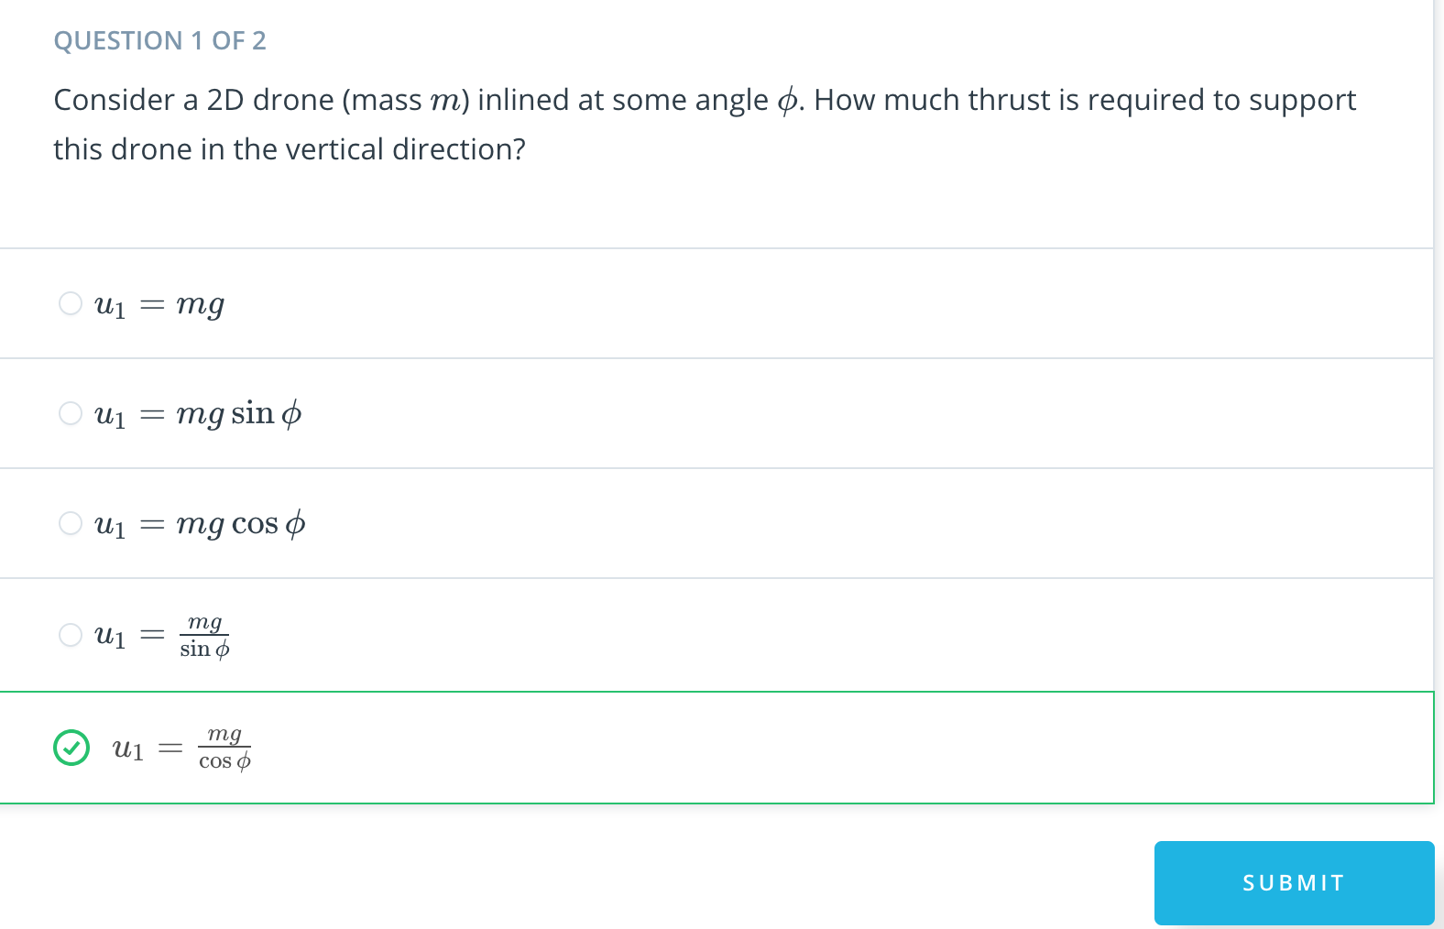

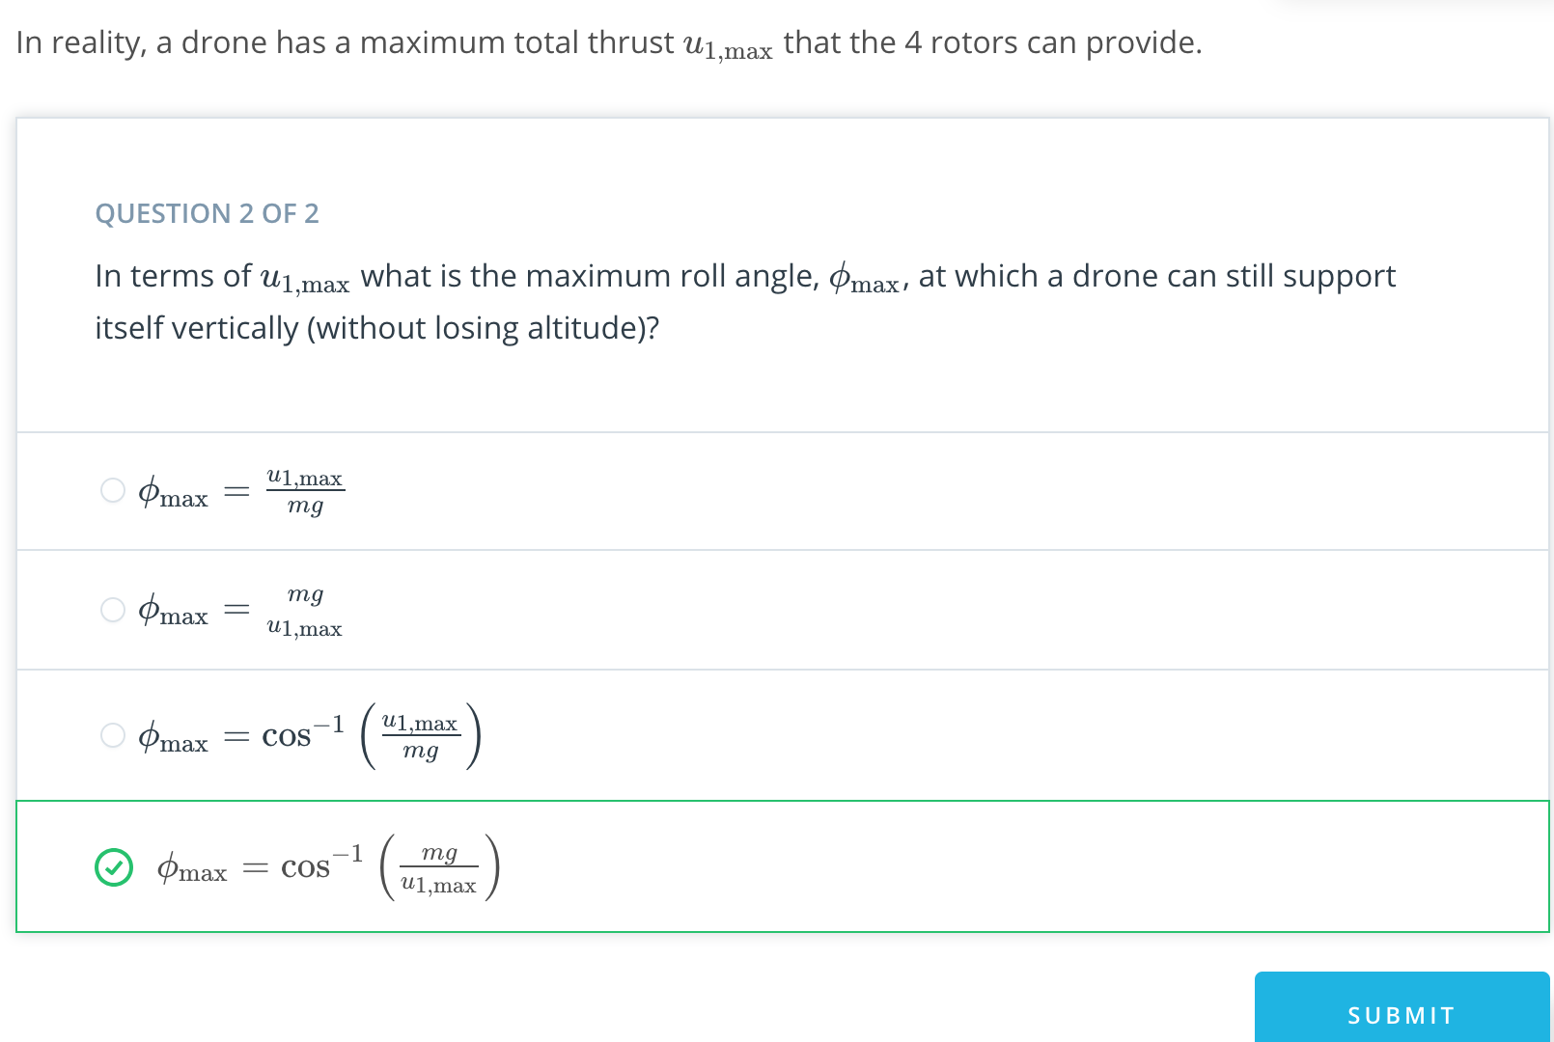

1. Lesson Overview

<https://www.youtube.com/watch?v=3M7K5qC1zq0>

1. Motivation for Linearization

<https://www.youtube.com/watch?time_continue=4&v=UmV-KSARONs>

1. Linearization Math

<https://www.youtube.com/watch?time_continue=1&v=SgDcWJ8lS4c>

1. Linearization Intuition 1

<https://www.youtube.com/watch?v=XBTgM0ibU2s>

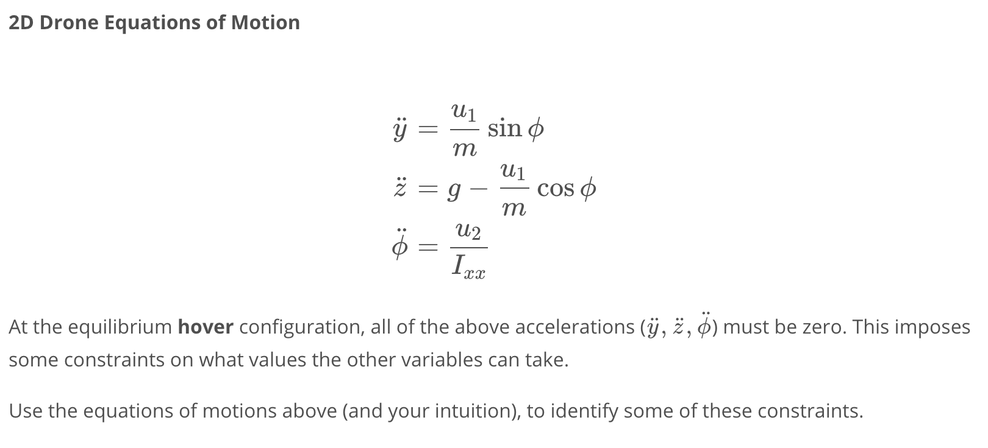

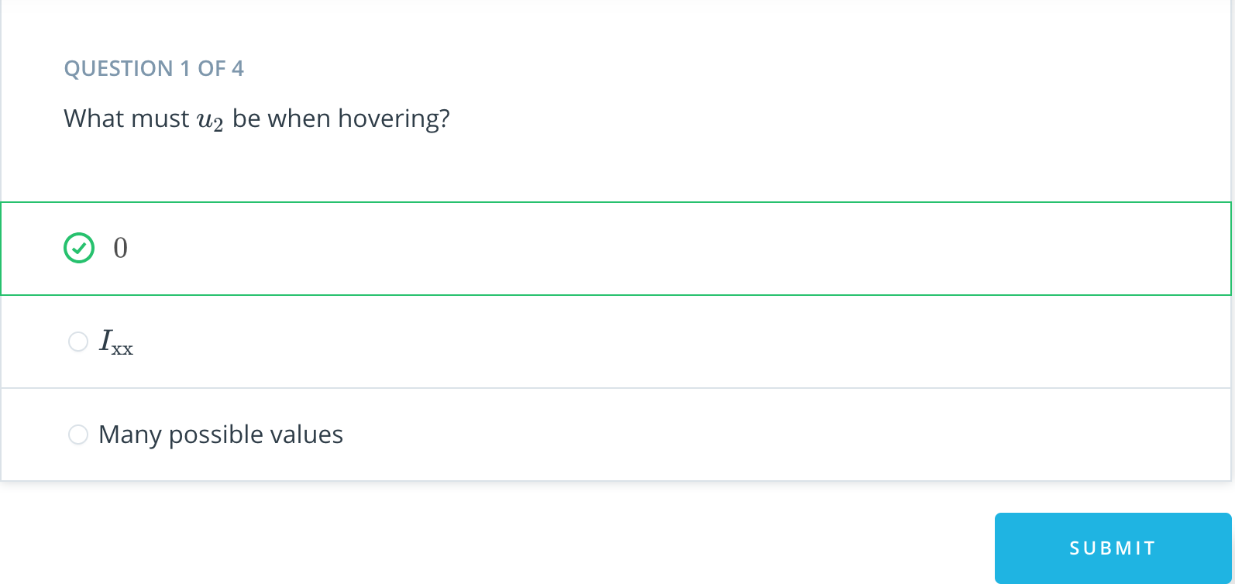

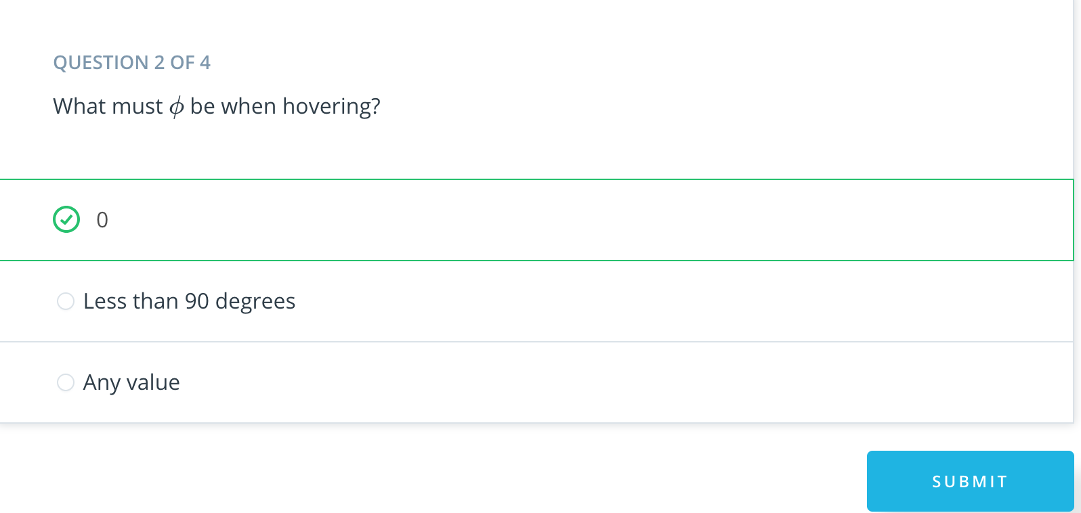

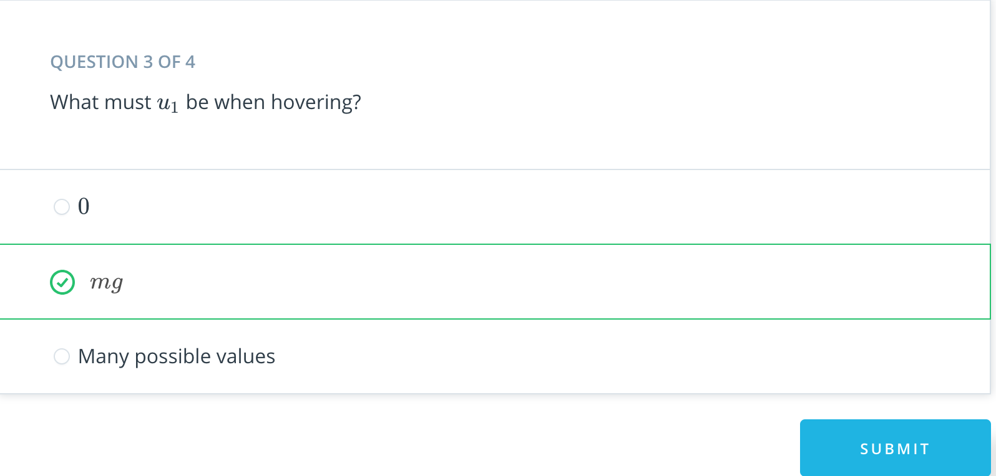

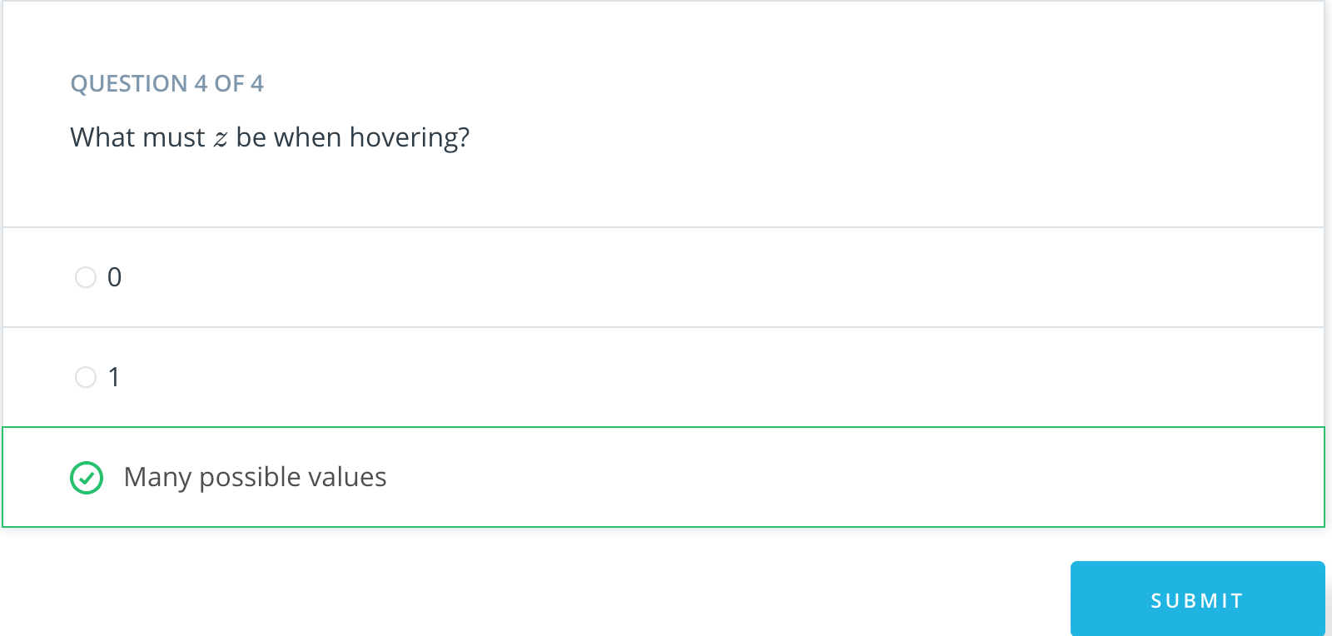

1. Linearization Intuition 2

<https://www.youtube.com/watch?time_continue=2&v=y5dUxtA_wC8>

1. Linearization Intuition 3

<https://www.youtube.com/watch?v=dZTiI1n3F5E>

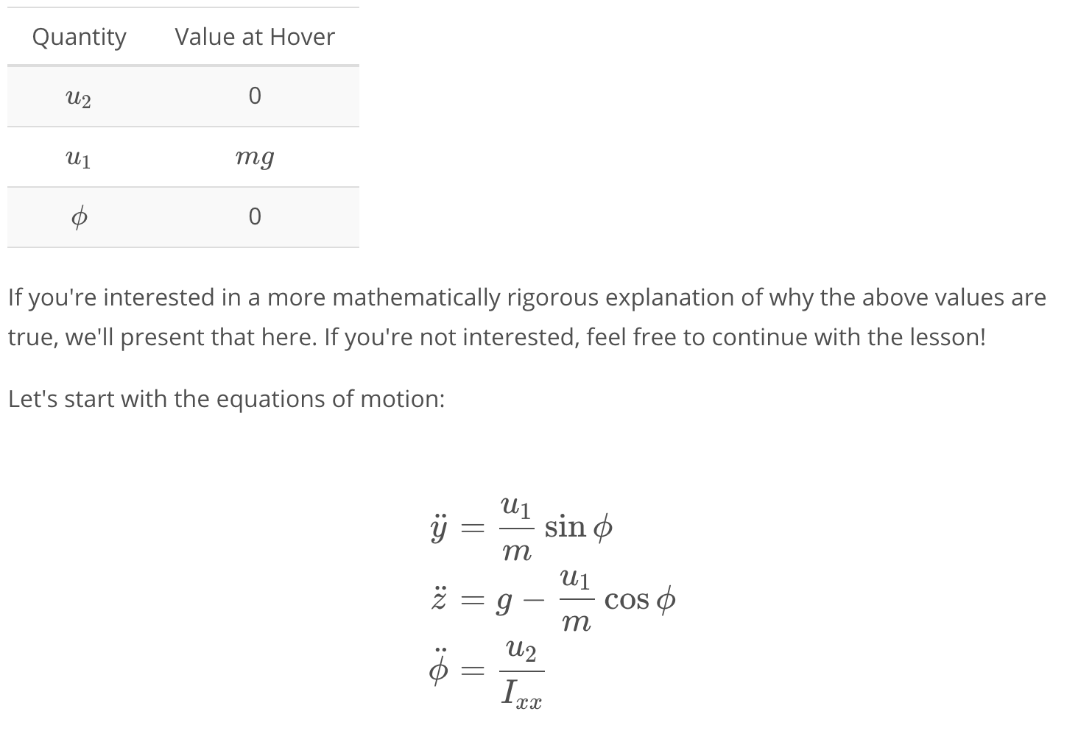

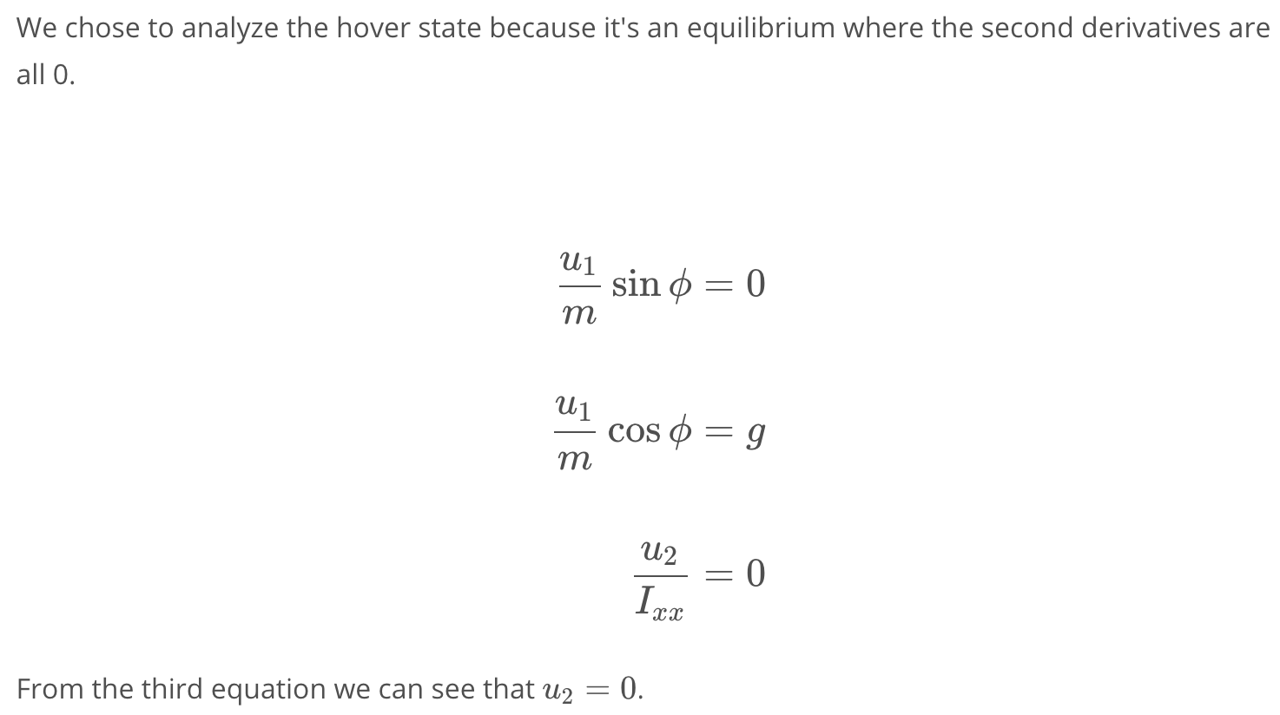

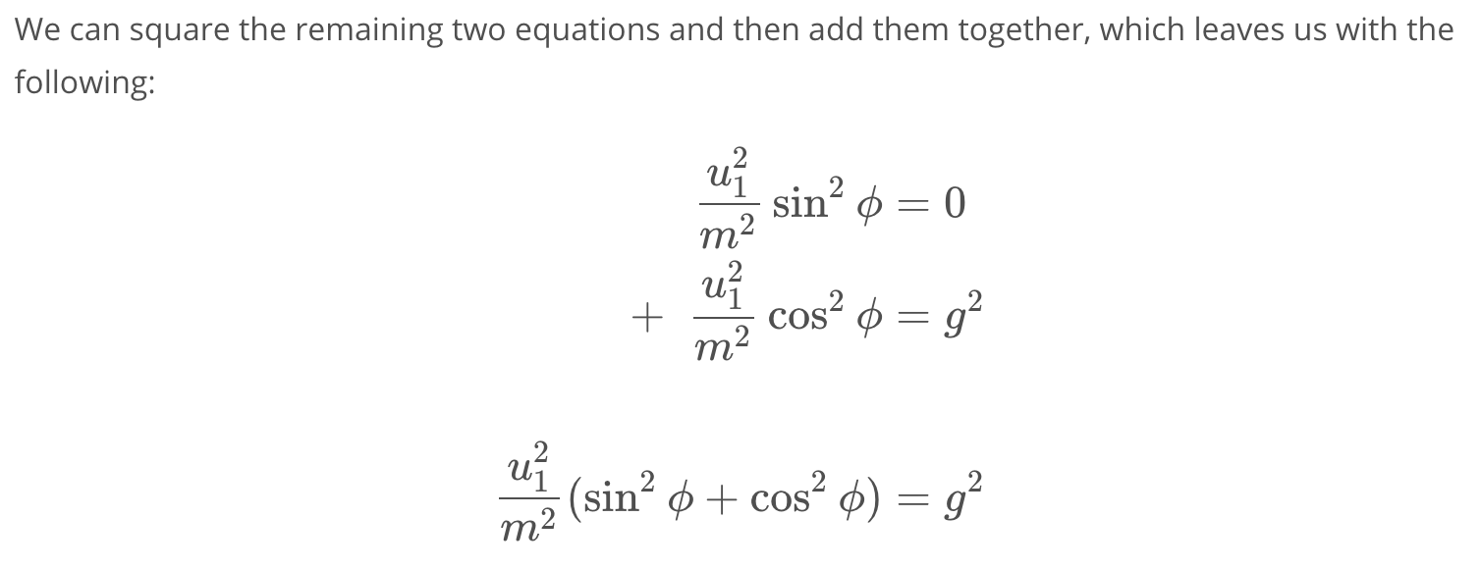

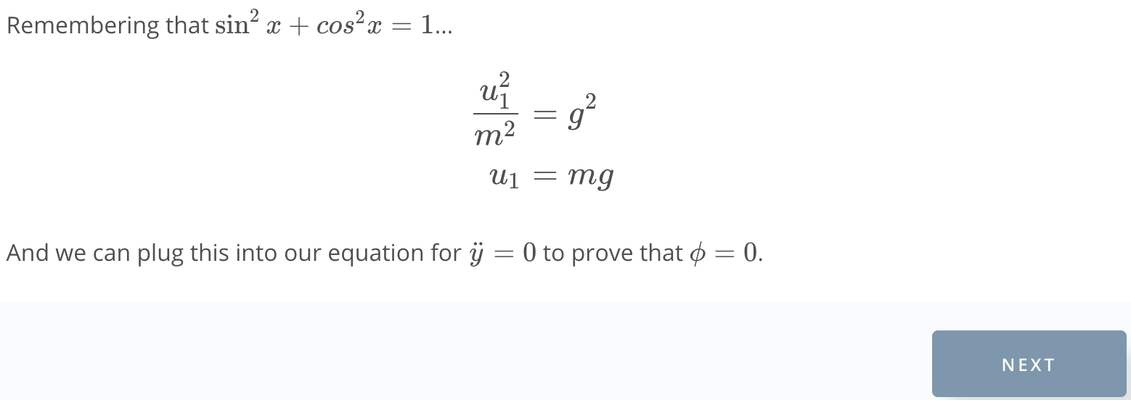

1. Linearization Exploration Exercise

Linearization.ipynb

1. Controling Motion Near Hover

<https://www.youtube.com/watch?v=jgUZzCSXPm8>

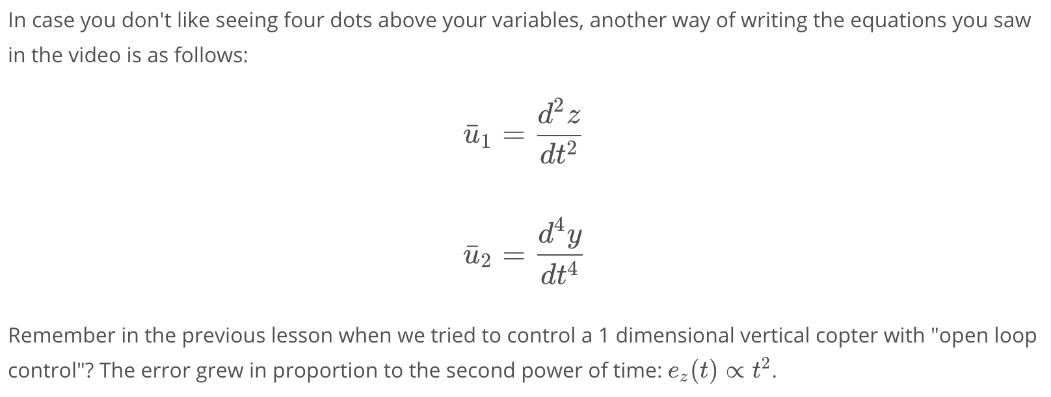

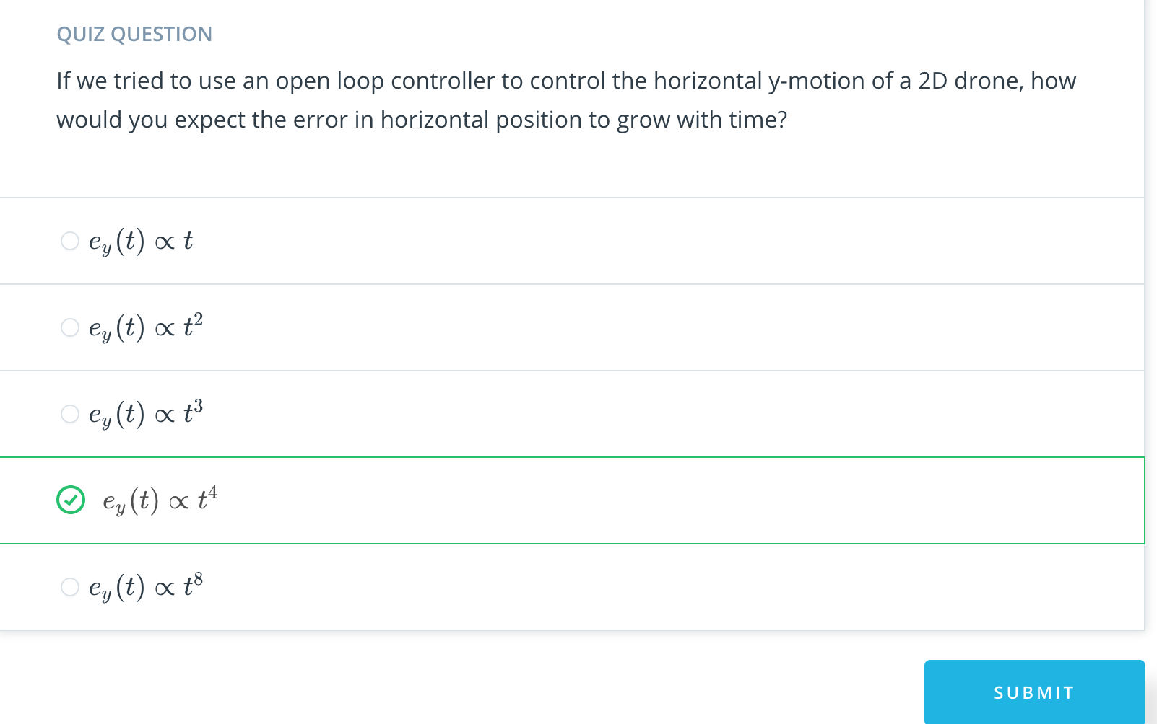

1. Intro to Cascaded Control

<https://www.youtube.com/watch?time_continue=1&v=FzObnvshV7Q>

1. Implement Linear Controller Exercise

Linear Controller.ipynb

1. Separation of time scales

<https://www.youtube.com/watch?v=2jAAsCvufl0>

1. Non-Linear Control

<https://www.youtube.com/watch?v=Tvu76GD8SyA>

1. Implement Non-Linear Controller Exercise

Non-Linear Controller.ipynb

1. Comparing Trajectories Exercise

[Comparing Trajectories.ipynb](https://viewc966e973.udacity-student-workspaces.com/notebooks/Comparing%20Trajectories.ipynb)

1. Summary

<https://www.youtube.com/watch?v=nRnULToP-jU>